Merche goes off to a meeting on the south of the island, you decide to go shopping. Remember the Guidebook thinks you’re British.
What does Merche do, accidentally? ______________________________________________________
What are these? (Don’t worry if you don’t get them all, he goes fast!)
Pantalones _______________________ Una camisa _______________________
Calzoncillos/bragas_________________ Un bañador ___________________________________
Zapatos _________________________ Una camiseta/un top _____________________
How do you ask for another color? ______________________________________________________
How do you ask for the dressing room? __________________________________________________
How do you ask for a larger size? _____________________________________________
A smaller one? ________________________________________________________
¿Cuánto cuesta la camiseta? ___________________________________________________________
What would YOUR shoe size be? ____________________________________________________
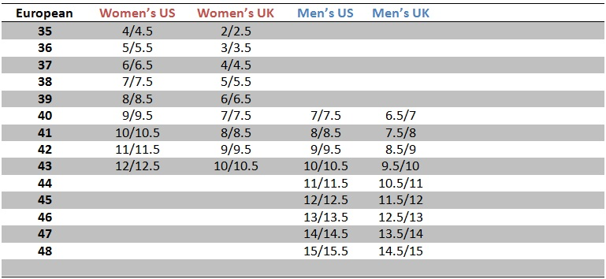
How would you say/ask for your shoe size in Spanish? _________________________________________
How do you ask for a larger/smaller SHOE size? ______________________________________________
What is the difference between “talla” and “número”? ________________________________________
Write 4 additional clothing items and their translation here:

Who do you have to meet? ____________________________________________________________
You will take the “guagua”…what is the other Spanish word we’ve learned for this? _____________________
LEARNING SECTION: VOCABULARY
How do you tell a salesperson you’re just looking? ________________________________________
How would you ask “Where is the dressing room?” _______________________________________
LEARNING SECTION: GRAMMAR
What are uses/meanings of “Poder” and its forms? __________________________________________
How do you say, “She can”? ______________________________________________________________
How do you say, “We can”? _____________________________________________________________
Read the second page about adjectives. Then tell me the 3 other forms of these two adjectives:
Guapo ________________ _________________ ______________________
Bueno ________________ _________________ ______________________
LEARNING SECTION: PRACTICE
Write the words, with the correct endings on their adjectives:
Una falda blanc__ Un bañador negr___ Un top naranj____
Unos pantalones azul__ Unos zapatos verd___ Unas bragas roj___

Fill in the message, saying and asking about who CAN do things:
Yo no __________ hoy. ¿Tú _______________ mañana? Tú y yo _________________ ir de compras y mis padres _______________________ ver el centro.

