You’re back a home. What a memorable trip, right?

Read Merche’s article. Write a summary of what you can understand from each screen of the article.
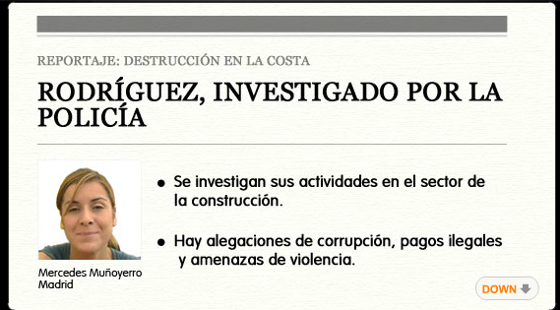
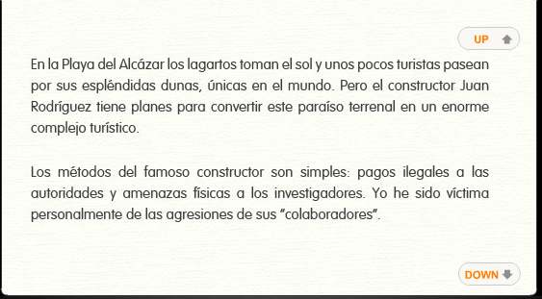
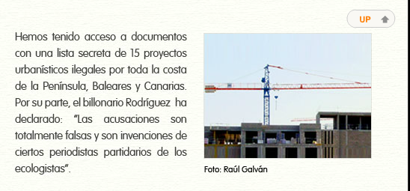

What are 2 things Merche’s video message tells you? _______________________________________
___________________________________________________________________________________
Who does Merche ask you about? ________________________________________________________
CLICK ON MERCHE’S LETTER. Do you agree or disagree with the results of the poll? Why? ____________________________________________________________________________________
Click on the red link to read others’ thoughts. This will take you to the regular web page. Read a few comments. What is your opinion now? ____________________________________________________
_____________________________________________________________________________________

From the LEFT menu click on “TV Drama” (it won’t load correctly), then use that menu to find Episode 22. Click by the Guidebook’s photo to “Take The Test”.
Take the test, then show me your final score.

